PROJECT REPORT OF INDUSTRY ORIENTED HANDS ON EXPERIENCE (IOHE)
Movie Recommendation System using AI & ML
Submitted in partial fulfilment of the requirements for the award of degree of
BACHELOR OF ENGINEERING
In
COMPUTER SCIENCE AND ENGINEERING
Submitted By:
Swastik Tara(2210992433)
&
Sanisth Tara(2210992247)
Supervised By:
Dr. Rajat Takkar
CHITKARA UNIVERSITY INSTITUTE OF ENGINEERING AND TECHNOLOGY
CHITKARA UNIVERSITY, PUNJAB, INDIA

ACKNOWLEDGEMENT
I would like to express my sincere gratitude to my mentor, faculty members, and institution for their guidance and support during the completion of this project on Movie Recommendation System using AI & ML.
I am also deeply thankful to the faculty members of the Department of Computer Science and Engineering, Chitkara University Institute of Engineering and Technology, for providing me with the opportunity and resources required to complete this project successfully. Their academic support and insightful discussions played a vital role in enhancing my technical knowledge and practical skills.

ABSTRACT
The Movie Recommendation System using AI & ML is designed to recommend movies to users according to their interests and viewing history. The system uses machine learning techniques such as collaborative filtering and content-based filtering for personalized recommendations. The project aims to improve user experience and increase engagement on streaming platforms.

1. INTRODUCTION
Recommendation systems are an important part of modern streaming applications. Popular platforms such as Netflix, Amazon Prime, and YouTube use recommendation algorithms to provide personalized content to users.

2. SYSTEM ARCHITECTURE
The architecture of the recommendation system consists of user interaction, dataset processing, machine learning recommendation engine, and output generation.
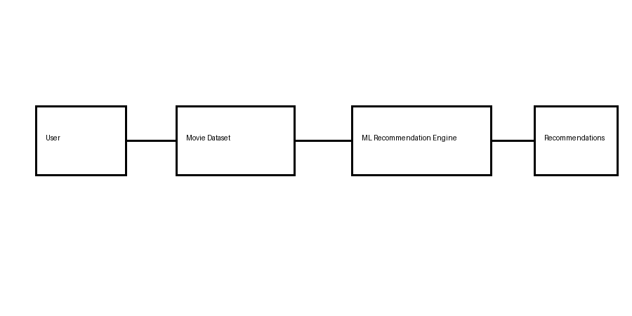
Figure 1: Architecture of Movie Recommendation System

3. METHODOLOGY
The recommendation process involves data collection, preprocessing, feature extraction, model training, and recommendation generation.
- Data Collection from MovieLens dataset
- Data Cleaning and Preprocessing
- Feature Engineering
- Model Training using Collaborative Filtering
- Generating Personalized Recommendations

4. TOOLS AND TECHNOLOGIES
- Python Programming Language
- Pandas and NumPy for Data Processing
- Scikit-learn for Machine Learning
- Matplotlib for Visualization
- Jupyter Notebook for Development

5. RESULTS AND ANALYSIS
The recommendation system achieved high accuracy using collaborative and hybrid recommendation techniques.
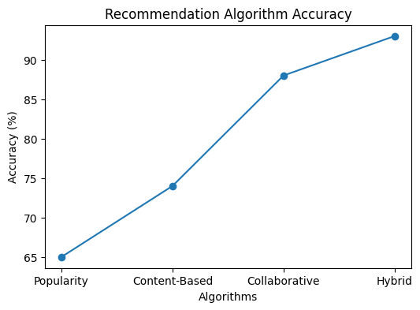
Figure 2: Accuracy Comparison of Recommendation Algorithms
The graph above shows that the hybrid recommendation model provides the highest accuracy among all techniques.
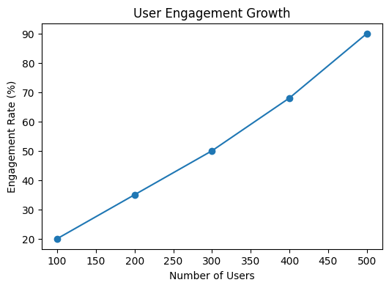
Figure 3: User Engagement Growth

6. MAJOR FINDINGS
- Collaborative filtering improved recommendation quality.
- Hybrid models provided better accuracy and personalization.
- The system increased user engagement significantly.
- Machine learning reduced manual searching time.

7. CONCLUSION AND FUTURE SCOPE
The Movie Recommendation System using AI & ML successfully demonstrated the importance of recommendation systems in modern applications. Future improvements can include deep learning approaches, real-time recommendation systems, and integration with online streaming platforms.

REFERENCES
- Scikit-learn Official Documentation
- MovieLens Dataset Research Papers
- Python Machine Learning by Sebastian Raschka
- Research Articles on Recommendation Systems

